Assignment 1: Exploring Weather Trends - Project

1. Extract data

I pulled out all of the dataset by using SQL:

1. City_data:

SELECT * FROM city_data

1. City_list

SELECT * FROM city_list

1. Global_data

SELECT * FROM global_data

1. Open up the CSV

I download the result from previous task to achieve 3 .csv files. I manage to open the up them in excel files:

1. The result of city_data: an excel file with 4 columns – year, city, country, and avg_temp for every year in each city which the list is in city_list file

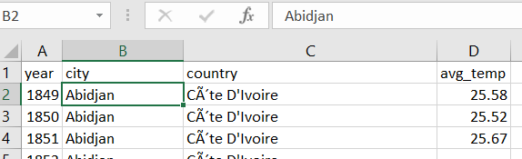

1. City_list file: An excel file with 2 columns – city and country correspond with this city

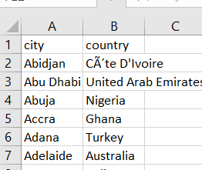

1. Global_data: an excel file shows the global temperature’s observation each year, from 1750 o 2015

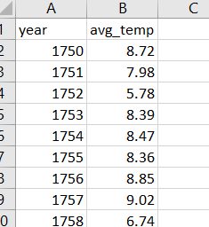

1. Select the cities to compare the temperature: I am living in Perth, Australia. So, it should be my fist selection. I was born in Hochiminh city. So, it pick it up as the second entities. I will choose 2 others by querying the city which the overall evg_temp are highest and lowest.

From the city_data sheet, I generate a pivot table with the row is city name, columns are each observation year and the grand total is average of avg_temp in the city per number of observation’s year.

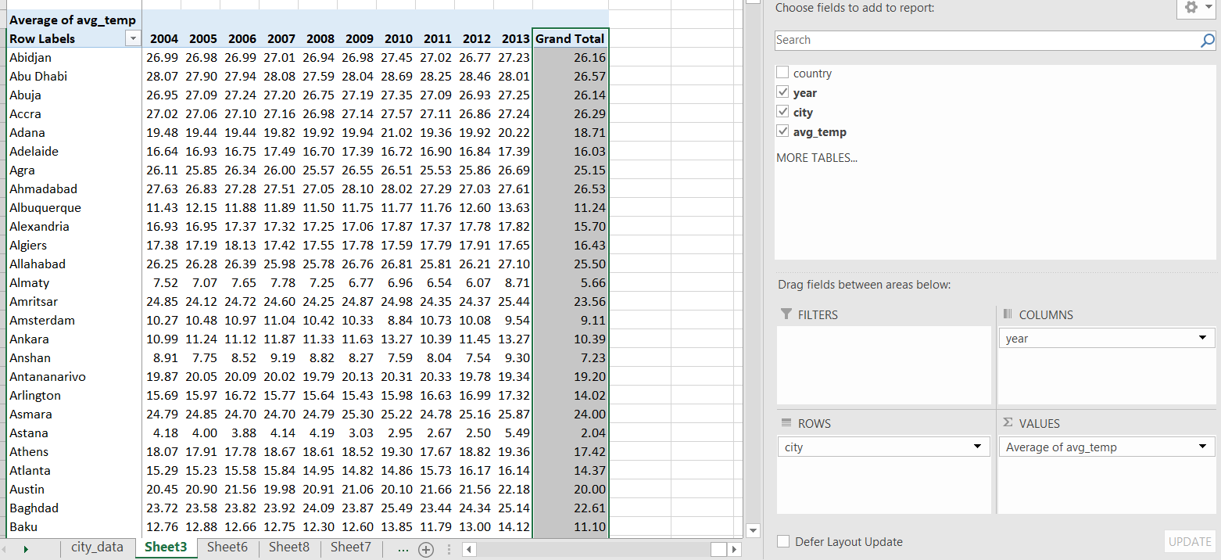

From the Grand Total column, which indicate the average of agv_temp in each city, I extract the highest and lowest values and city corresponded with those values. So, the final selection to be appeared as list:

|  |  |  |
| --- | --- | --- |
| Selected cities compared with global data | |  |
| **City** | **Total Count of avg_temp** | **Total Average of avg_temp** |
| Ulaanbaatar | 72.93% | -3.37 |
| Khartoum | 56.02% | 29.06 |
| Ho Chi Minh City | 65.41% | 27.18 |
| Perth | 53.38% | 18.26 |
| Global | 100.00% |  |

The table shows the name of 4 selected countries, indicate by total of non-missing values (the percentage of years the value is not missing compared with total observation’s years which taken in global data), total Counts of avg_temp, and overral average of avg_temp

1. Create the line chart
   1. Merge city_data table with global_data

From city_data excel -> Data -> Filter ->Select Perth from list of city name, we got the filter table of Perth’s temperature data over the observation years

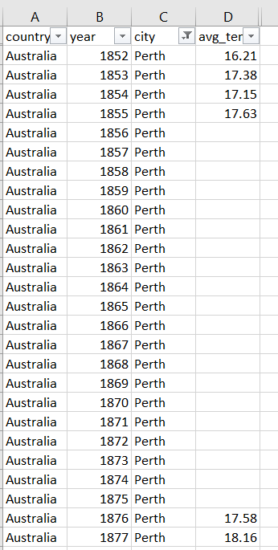

From global_data, using VLOOKUP function to query temperature values of Perth based on observation years. The missing value would be returned by #N/A value. This values need to be eliminated by Find #N/A and replace by blank

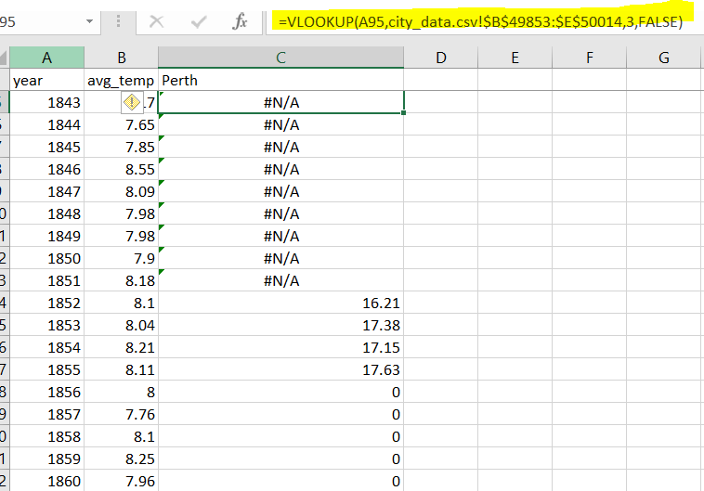

Do the same for others cities, the results we got is the temperature table of selected city compared with global_data:

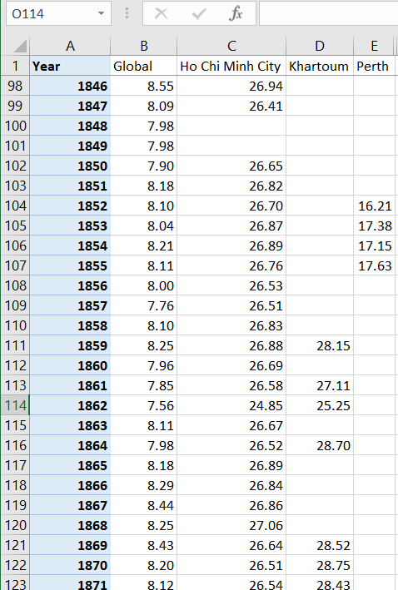

* 1. Moving average: I choose 10 years is the averaging of moving as during around 10 years since the length of observation is pretty long (203 years)
  2. Line charts:

The line chart shows the trend of average of temperature yearly. Y axis indicates the temperatures in C degree while the X axis shows the range of observation years in which the observation values in Perth city is available to pick up.

1. Make observations:
   1. The trend of temperature is gradually increase over the time
   2. The trend of temperature in Perth city yearly is quite identical compare with the trend of temperature in global, indicated by two parallel trend line. So, from the observation’s value of global data, it can be predicted the temperature of Perth city in that year.
   3. The range of average temperature in global varies from 7.203 to 9.594 degree compare with 16.21 to 19.28 in Perth
   4. From the years of 1970s, the trend of temperature in the world tends to crease faster compare with prior.